**Question 6**

**Modification Commands**

1. Description: We have fired all the employees that have not handled any order during their time as an employee, so this modification deletes these employees.

**DELETE FROM** EMPLOYEE **WHERE EID IN** (**SELECT EID  
FROM** EMPLOYEE  
**WHERE EID NOT IN** (**SELECT EID FROM** EMPLOYEE, **ORDER  
WHERE** EMPLOYEE.**EID** = ORDER.HANDLER))

These are the entries deleted:

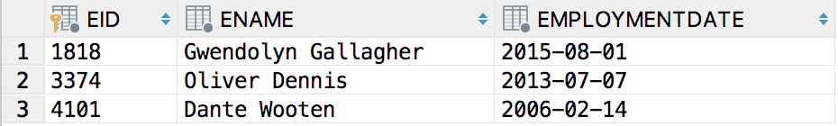

Screenshot of script running:

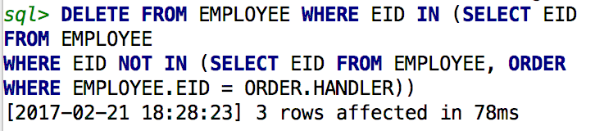

1. We are low on employees, so we decided to hire every customer that made a purchase from us since January 10, 2017. This command will insert five new employees into our employee table.

**INSERT INTO** EMPLOYEE  
 (**SELECT ORDERID as** EID, (**FIRSTNAME** || **' '** || **LASTNAME**) **as** ENAME, **ORDERDATE as** EMPLOYMENTDATE  
 **FROM** CUSTOMER, **ORDER  
WHERE** CUSTOMER.**EMAIL** = ORDER.**CUSTOMEREMAIL  
AND ORDERDATE** >= **DATE '2017-01-01'**)

These are the entries inserted:

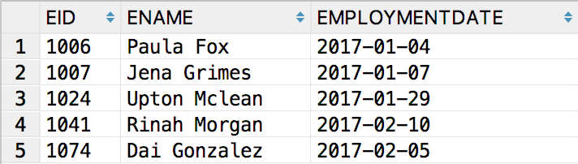

Screenshot of script running:

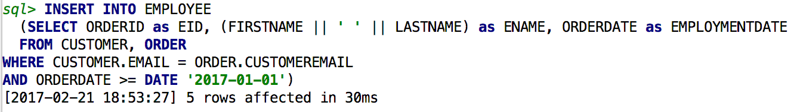

1. Description: We have increased our inventory for all items that had stock below 80 in our Toronto location. This modification updates the quantity available column by adding 100 to its current value in each entry that has less than 80 inventory.

**UPDATE** UNITSTOCKING  
**SET QUANTITYAVAILABLE** = **QUANTITYAVAILABLE** + 100  
**WHERE QUANTITYAVAILABLE** < 80 **AND LOCATION** = **'TORONTO'**

These are the entries updated:

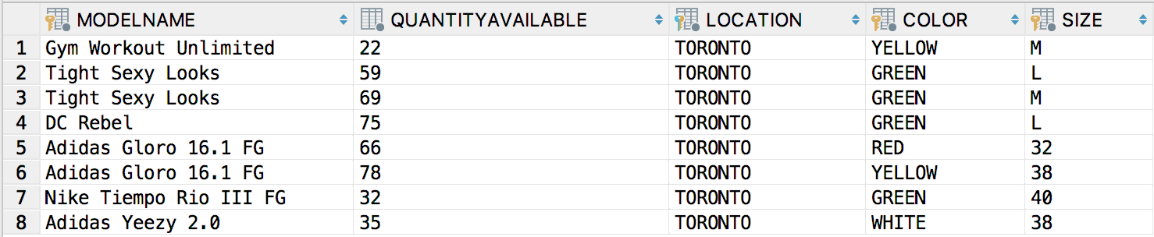

Screenshot of script running:

